Ideation Phase
Brainstorm & Idea Prioritization Template
Date | 27 February 2026
Team ID | LTVIP2026TMIDS78907
Project Name | Optimizing user, group and role management with access control and workflows
Maximum Marks | 4 Marks

Brainstorm & Idea Prioritization Template:
Brainstorming provides a free and open environment that encourages everyone within a team to participate in the creative thinking process that leads to problem solving. Prioritizing volume over value, out-of-the-box ideas are welcome and built upon, and all participants are encouraged to collaborate, helping each other develop a rich amount of creative solutions.
Use this template in your own brainstorming sessions so your team can unleash their imagination and start shaping concepts even if you're not sitting in the same room.
Reference: https://www.mural.co/templates/brainstorm-and-idea-prioritization
Step-1: Team Gathering, Collaboration and Select the Problem Statement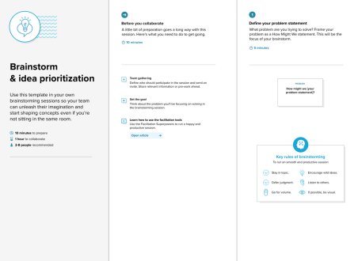
Step-2: Technology used
During brainstorming, the team evaluated various technologies suitable for implementing a scalable and secure access management system.
Technologies considered:
• Backend: Java / Spring Boot
• Frontend: Angular / React
• Database: MySQL / PostgreSQL
• Authentication: JWT / OAuth
• Access Control Model: Role-Based Access Control (RBAC)
• Workflow Engine: Rule-based approval workflows
• Version Control: Git
• Deployment: Cloud or on-premise server
Selection Criteria:
• Security strength
• Scalability
• Ease of integration
• Performance efficiency
• Community support
Step 3: Idea Prioritization
After generating multiple ideas, the team performed prioritization to identify the most impactful and feasible features for implementation.
Prioritization Method:
Ideas were evaluated based on:
• Impact on security
• Implementation feasibility
• Time and resource requirements
• Scalability benefits
• User experience improvement
Priority Level Selected Ideas
High Role-Based Access Control, Automated Workflows, Audit Logging Medium Centralized Dashboard, Group Permission Inheritance Low Advanced analytics (future scope)

